POLICIES AND PROCEDURES

OSL.SOP.XVII.009
#29 Ebola vaccines vials disposal and waste management
WRE/SHO
OSL Standard Operating Procedure
Target Audience: Technical Logistic officers

DISCLAIMER

Standard Operating Procedures (SOPs) provide a step-by-step guide for staff directly involved in the processing of administrative actions to support and facilitate the implementation of WHO policies and procedures. The SOPs are for guidance only; they are neither authoritative nor binding. The SOPs reflect the policies and procedures of WHO at the time of writing; however, policies and procedures change from time-to-time. In the case of a conflict between the SOPs and the WHO e-Manual provisions, the WHO e-Manual provisions take precedence.

DOCUMENT SPECIFICATIONS

Version Version | Date of revision | Author (s) / Dept / Unit | Approver | Indicate which section (s) changed compared to previous version
0.1 | Jan 2019 | Jordi Sacristan / SHO/OSL | MOLINARO, Paul; COSTA, Alejandro;  AIT-IKHLEF, Kamal; | To be reviewed and cleared

INTRODUCTION

  - Purpose
The purpose of this Standard Operating Procedure (SOP) is to describe the detailed process on how to manage empty Ebola Zaire vaccine (V920) vials and associated waste after EVD vaccination activities have ended. Explicitly on how to perform the appropriate collection, treatment and correct final disposal of them, according to the context, and aiming to minimize any health risk associated.
  - Scope
The information described in this SOP is for study staff involved in medical waste management, produced during vaccination activities (both Vaccination Rings following confirmation of a case of Ebola Virus Disease (EVD), and front-line health workers at risk).
  - Principles
All EVD vaccine vials used (and the waste produced by all consumables associated) must be safety collected, treated and finally disposed, as part inherent of any vaccination activity.
Used EVD vaccine vials and associated ancillaries are very sensitive material, and they must be collected, treated and disposed in a correct and safe manner, by well-trained staffs under the supervision of HCWM specialist.
Responsible personnel should ensure that the waste management procedures are correctly applied all time, and that supporting infrastructures are available and functional at the start of EVD vaccine activities.

MATERIALS:
  - Plastic container with cover (for collecting EVD vaccine empty vials).
  - Safety Boxes, for sharps collection.
  - Incinerator, ash and sharp pits.
  - Cement bags, lime and water, and drums.
  - PPE sets (surgical gloves, heavy-duty gloves, goggles, boots, mask, gown, etc.)

PROCEDURES
  - Pre-assumptions:
    - EVD vaccine empty vials and associated waste management plan must be incorporated within the operational strategy for vaccination from the very beginning, as an integral part of the whole process, thus it is planned, allocated required resources and a budget.
    - Required structures devices are pre-identified and in place, available and functional.
    - Staff involved on the EVD waste management must be identified and properly trained on their technical specifications, and in general knowledge on WHO’s HCWM principles and procedures.
  - Collection of the used EVD vaccine vials and the rest of associated waste during the vaccination activity:
    - Any used EVD vaccine vial used, must be separated and safely collected from the rest. Both the totally empty vials, and the ones open but not finished at the end of the day’s activity, will be collected and kept by the team responsible to be counted; and for vaccination activity analysis.
    - Empty or opened EVD vials (in the field) will be collected inside a rigid, safe-closable and portable plastic container, properly labelled and all time supervised at the vaccination ground level.
    - In parallel, all sharp waste (needles, auto-block syringes, scalpels, etc.) must be collected inside an appropriate and dedicated container (Sharp Container or Safety Box).
    - The rest of solid waste (paper, used PPE, bandages, etc.) must be collected apart, inside a plastic bag, properly identified and labelled (biohazard waste).
    - At the end of the day and at the return to the base, when counting and registering number of vials used is completed, they may be transferred to a centralized rigid, safe, and closable collecting plastic container, for their further treatment (if possible), and for its final disposal.
    - Clean and disinfect field containers, to make them available for the next day.
    - Keep all waste generated during EVD vaccination (vials, “sharps” and rest of the “solid waste”) at the operational base, in a closed and secure place — with limited access to the responsible person only —, until waste’s appropriate treatment (if possible) and/or its direct final disposal.
  - Treatment of the used EVD vaccine vials prior its final disposal:
    - Used and discharged EVD vaccines vials, may be treated only if the appropriate and reliable facilities are in place and functional; before their final disposal. Otherwise, no treatment process will take place. For correct treatment, vials will be incinerated in “high temperature” incinerators only (capable to reach minimum 1400 °C). There are two possibilities:
      - The use of a dedicated high temperature incinerator, designed for medical waste treatment.
Note: This type of incinerators is very specific, expensive and rarely present in the environment or contexts where vaccination takes place. Therefore, it may be necessary to assess the possibility to include the purchase and its installation according to volume of waste and number of vials.
      - The use of an existing cement factory “kiln” in country, prior agreement with the owner and after establishing all required protocols and procedures regarding both safety and security.
  - Treatment of the rest of associated waste:
    - Sharp waste (needles, scalpels, etc.), will not be treated. They will be collected in a dedicated “Sharp Container” (Safety Box), and without any additional treatment will be disposed (with the container, without removing them from inside) directly into a “Sharp Pit”.
Note: Incineration is not an option either as you need high temperature to melt the needles (more than 1400 °C) and the process may cause oxidation of metals creating new risks for a still sharp waste.
    - The rest of the solid waste fraction must be treated by incineration using an appropriate incinerator able to reach high temperatures (more than 800 °C), with double chamber to reduce emissions of toxic gases. Ashes will be finally disposed.
  - Final disposal of the used EVD vaccine vials:
    - EVD vials -if not incinerated as described above — may then be safety and finally disposed, thus neither being accessible for re-use, nor being an environmental / health threat.
    - EVD vaccine vials may not be ever crushed, and if there is enough capacity may be properly disposed of inside a sharps pit” (be aware that this cause reduction on life span of the pit, due to occupied volume by air).
    - In the absence of any dedicated structure (i.e. Sharps pit), vials may be encapsulated (but not crashed); thus, preventing them for being reused, accessible and dangerous for both population and environment.
Encapsulation: Place used EVD vials in a container, mixing them within a cement, lime and water mixture (3/3/1 parts by weight) in a sealed drum (metallic).
    - Once mixture is solidified, the whole block can be buried, in a dedicated dumping area, within a hospital / health centre or any proper identified place.
  - Final disposal of the rest of associated waste:
    - “Sharp waste fraction”, will be directly disposed — without previous treatment — inside the dedicated “Sharp Pit” previously identified in a selected Health Structure.
    - “Solid waste fraction”, will be disposed inside the dedicated “Ash Pit”, after its treatment through incineration, in a previously identified existing structure in the selected Health Structure.

REFERENCE MATERIALS
  - Related SOPs
- SOP#31_WRE-SHO-OSL- Setup of Ultra-Cold Chain for EVD vaccination.
- SOP#_WRE-SHO-OSL- Packing EVD Vaccine for transportation to the Field.
- SOP#32_WRE-SHO-OSL- UCC Decommission.

Waste Management Chart:

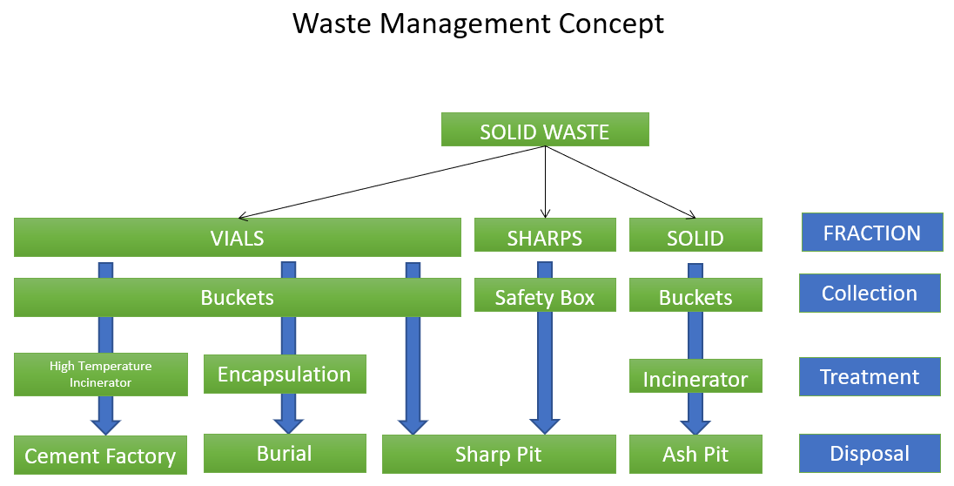

APPENDIX

1. GLOSSARY:

SOP: | Standard Operational Procedure.
HCWM: | Health Care Waste Management.
EVD: | Ebola Virus Diseases.
PPE: | Personal Protective Equipment.
Sharps Container: | Container dedicated specifically to contain sharps (needles, syringes, etc.), containing them in a secured and safe way, to prevent punching accidents and blocking transmission of diseases.
Safety Box: | See “Sharp Container”.

